I want to find a document about in a workplace ‘Application development method’ in Tuubi.
1. Login ->
2. Application development method (in workspace) ->
3. Document ->
4. Select folder
4 clicks for navigating the pages. It will take 1 minute if you are already familiar with the interface and it is really straightforward..

I want to get a recognition of previous study in Tuubi using eAHOT service.
1. Login ->
2. (eAHOT) under Student Tools ->
3. new Application ->
4. Mark the date and teacher who you had a discussion with ->
5. Choose courses to be included in the Recognition of Prior Learning application or add a course that is not included in your curriculum ->
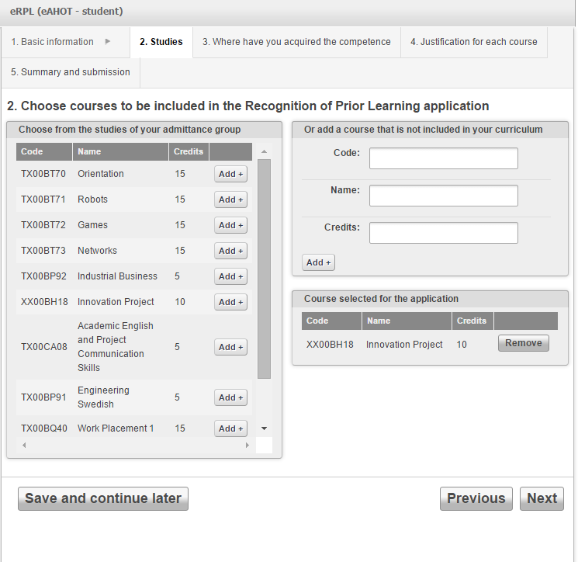
In this page, considering students are trying to include courses from other school or even other major, the name of the course is not likely in the choosing section. And it is not clear what code we have to type in instead and there is not clear instruction that is easy to find. Also European credit system(ECTS) is different from the Korean systems and there was no instruction as to how to convert credits from another country and I had to depend on google search.

6. Fill in information in which place you have acquired the competence(s) you wish to include in your application ->
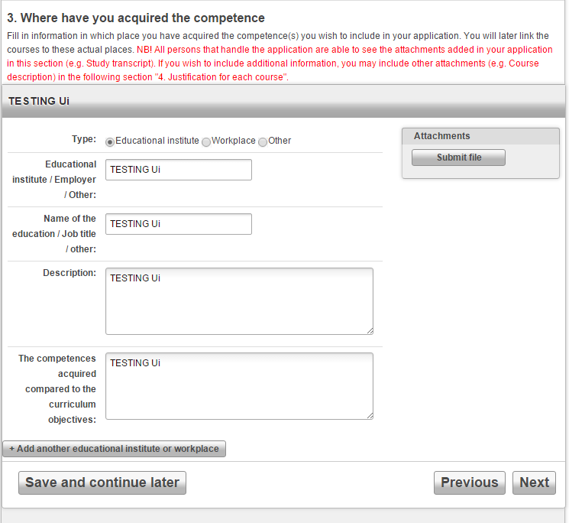
There is no ambiguous term here. Plain and clear.

7. Justification for each course ->
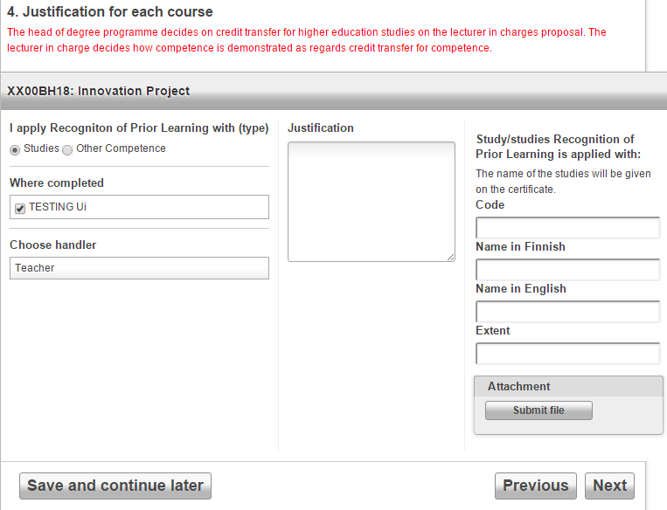
Here even though I am submitting only one type of Recognition of Prior Learning, which is “Studies” and one institution, which is “TESTING Ui”, the page still requires me to manually select the type and institution, which is unnecessary and can be avoided. And justification is again asked which I have no idea why it should be asked two times. And also the code is asked again and still doesn’t have the clear instruction on what to write there, and asking names both in Finnish and English is not necessary in my opinion because students only have to provide name in only one language according to which language is main language for the degree program he is attending. Also “Extent” I deducted this is some sort of grade or credits because only numbers are allowed in the field, but I am not sure what to write there since there is no instruction like other things. If they mean credits or grade by “Extent” they can change the wording to the mentioned words because they are more normally used and easy to understand.
8. Summary and Submission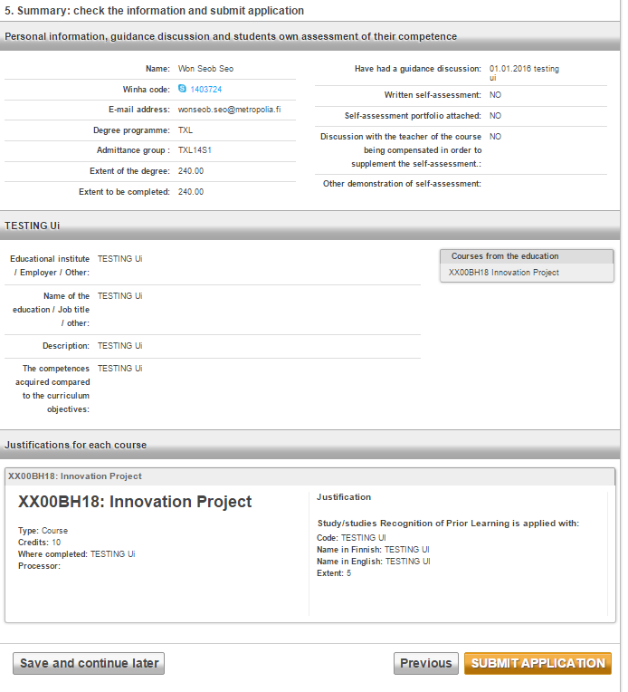
8 clicks for navigating the pages but far more clicks to focus each of the form fields and type in the information. It will take 5 ~ 15 minutes depending on how much information you put in the application. But first time I used it, it took me over 40 minutes because I did not know where to find menus and was not sure what to put in each field and also had to find all the documents for information. In conclusion this function of the website “Tuubi” can be improved by putting clear instruction or tutorial. Or even brief explanations when mouse is hovered over each field will do a good job. And it could reduce clicks and time consumption by automatically selecting the obvious choice for users.

